Saved post on linked for manual testing questions

Introduction should be very strong:

Explain about yourself, roles and responsibilities.

Functional questions:

**What is test strategy:**  The test strategy includes **introduction, resource, scope(autonmation, api, database testing) and schedule** for test activities, test tools, test priorities, test planning and the types of test that has to be performed.

**What is plan? Test plan includes testplan, testcases. expecting**

**Software testing life cycle:**

Software testing life cycle: The Software Testing Life Cycle (STLC) is a sequence of specific actions performed during the testing process to ensure that the software quality objectives are met. The STLC includes both verification and validation. ... It consists of a series of activities carried out methodologically to help certify your software product. STLC stands for Software Testing Life Cycle.

1. Requirement Analysis:
2. Test Planning:
3. Test case development
4. Test Environment setup
5. Test Execution
6. Test Cycle closure

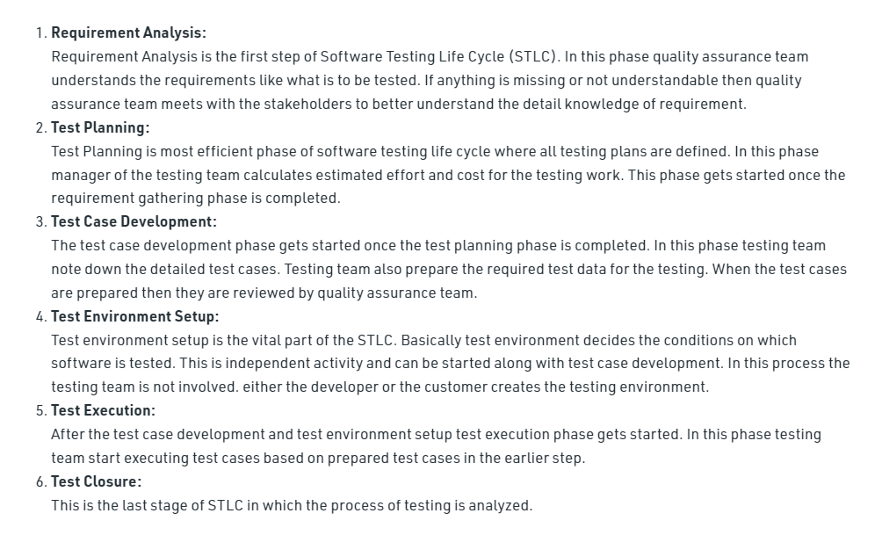

Test Planning: Includes test estimation during sprint refinement, how much time take each stories to create test cases and executing the testcase. And must  what are the testdata to be required for this as part of testing planning.

What are the 5 stages of STLC?

Design Phase. Implementation Phase. Execution Phase. Conclusion Phase.

**Unit Testing**

Validation of an individual software component or module is called Unit Testing. Generally, the developers perform it and not by the QA Engineers, as it requires detailed knowledge of the internal program design and code.

**Acceptance testing:** We perform this testing in the final phase of testing before moving the software application to the Market or Production environment. The client executes this type of testing in a separate environment (similar to the production environment) & confirm whether the system meets the requirements specifications.g

**What is Blackbox testing:** In the Black Box Testing method, testing happens without knowing the internal codes and structure of the program. The testing happens from the customer's point of view, and the tester knows only about the inputs and the expected outputs of the application. The tester is not aware of how the requests are being processed by the software and giving the output results.

**White Box Testing:** [***White Box Testing***](https://www.toolsqa.com/software-testing/white-box-testing/) is the testing method in which the tester knows the internal codes & structure of the software. The tester chooses inputs and executes the test by giving inputs to the system through the codes and determines the appropriate outputs. The main focus of ***White Box Testing*** is on strengthening the security and on improving the design and usability of the software.

 What we have come acIts kind API testing.

**Software development lifecycle?**

Requirement, system design, Development/Implementation, Testing, deployment and maintance.

**Testing methods: Black box testing, Whitebox and Grey box testing.**

It is the combination of Black Box testing and White Box testing. In Black Box testing tester is not aware of internal codes while in White Box testing internal codes of structures are known to the tester. In the Gray Box testing the tester has knowledge of some parts of internal structure.

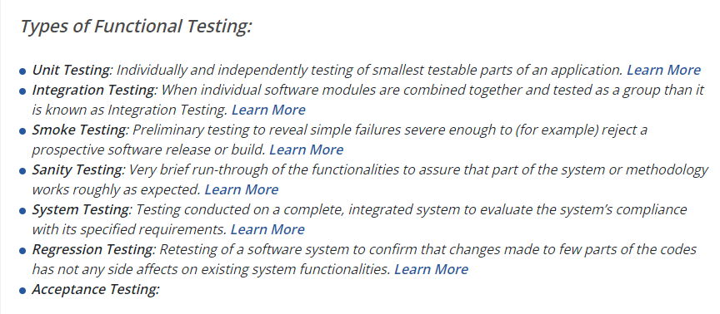

**System testing :** validation of complete and fully integrated software product to check the expected criteria met clients expection.

**What is automation testing :**

Automation[Testing](https://www.guru99.com/software-testing.html)is a technique using an automation tool to write and execute tester’s test scripts and cases.

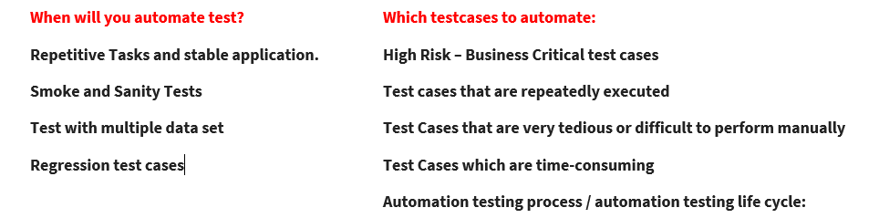

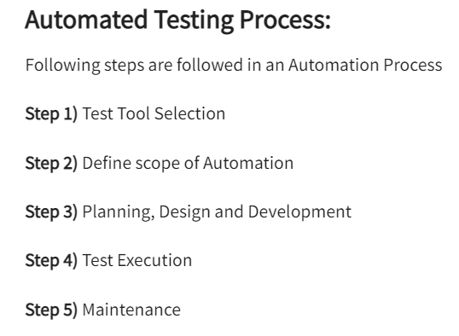

**Tool selection**:  Test Tool selection largely depends on the technology the Application Under Test is built on. For instance, QTP does not support Informatica. So QTP cannot be used for testing Informatica applications. It’s a good idea to conduct a Proof of Concept of Tool on AUT.

Explain we do we select selenium.

**Define scope of automation: in this scope, will decide which testcases to automated and technical feasibilities.**

1. The features that are important for the business
2. Scenarios which have a large amount of data
3. Common functionalities across applications
4. Technical feasibility
5. The extent to which business components are reused
6. The complexity of test cases
7. Ability to use the same test cases for cross-browser testing

**Planning, Design, and Development**

1. Automation tools selected
2. Framework design and its features
3. In-Scope and Out-of-scope items of automation
4. Automation testbed preparation
5. Schedule and Timeline of scripting and execution
6. Deliverables of Automation Testing

**Test execution:** designed automation testcases run on daily basis by categorizing. That is smoke testing, sanity testing and regression testing.

**Maintanace:** Test automation maintenance is **time spent rewriting or updating tests**. Test maintenance is required when the application undergoes change that would break existing tests. For example, a UI design update moves the button that a test clicks on, and therefore the test fails, even if the functionality still works.

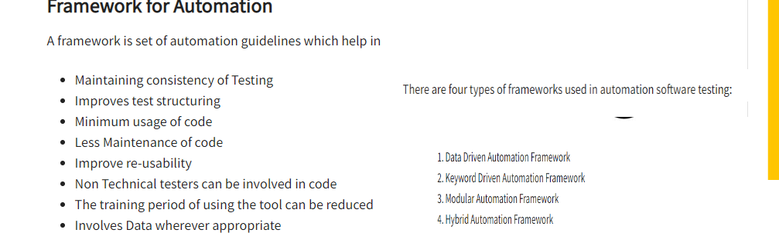

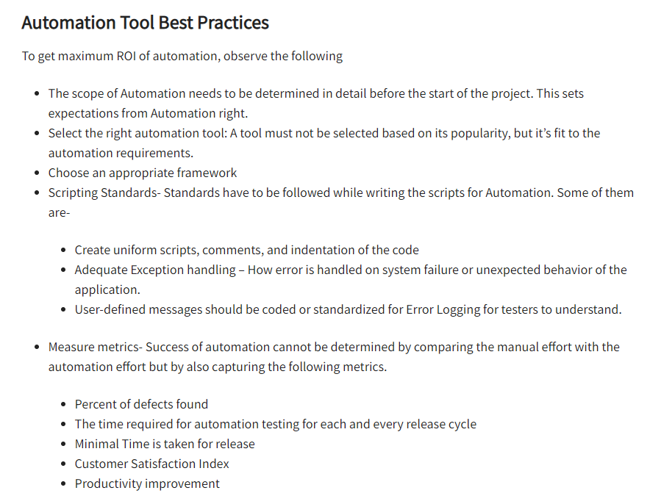

**Benefits of automation testing:**

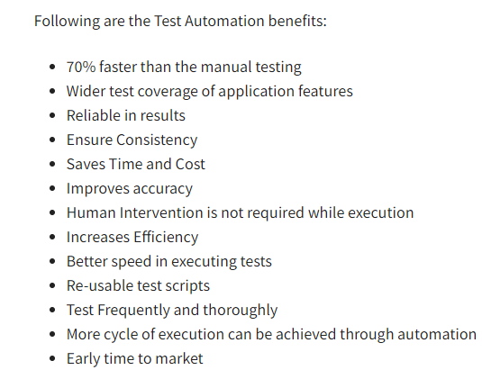

* **Reduces the man power.**
* **Wider test coverage,**
* **save time and cost,**
* **ensure consistency**
* **Increases efficiency.**
* **increased reusability,**
* **reduces the duplication of testing.**
* **Human intervention is not rquired while execution.**

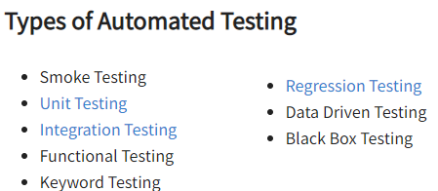

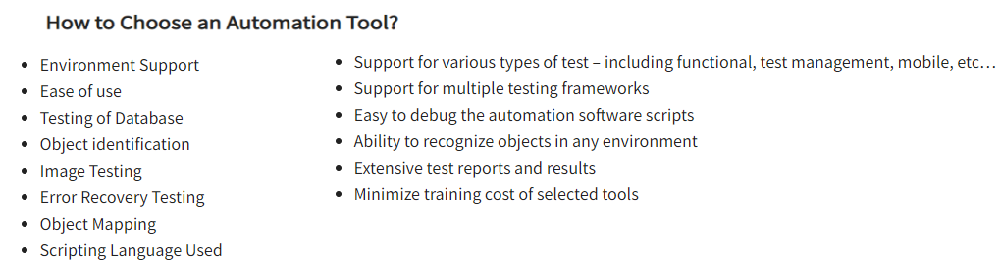

**What is Boundary Testing / test design techniques?**

**Data Input techniques:** Boundary testing is the process of testing between extreme ends or boundaries between partitions of the input values.

**Equivalent class portioning**: Equivalence Class Partitioning is type of black box testing technique which can be applied to all levels of [software testing](https://www.guru99.com/software-testing.html) like unit, integration, system, etc. it completely works based on the input. We can divide the input with valid invalid inputs, will be testing the behavior of the application for those inputs.

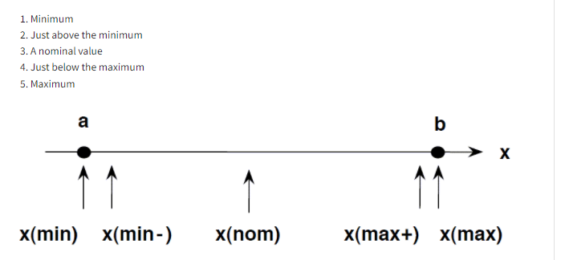

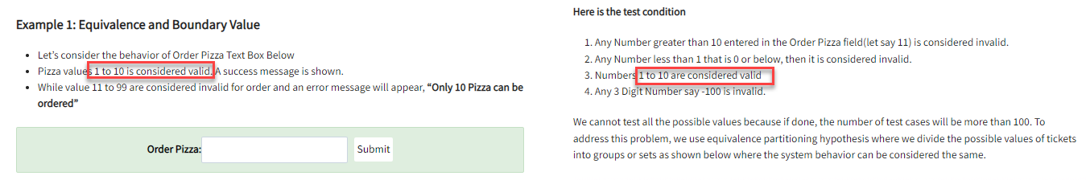

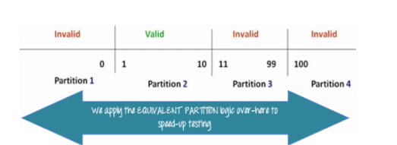

**Ex: out of office:** passed dates are invalid and present and future dates of the same will be valid. Future dates of 2022 January dates will also be invalid.

This will be valid only with current dates and future dates of the same year.

**Boundary value analysis: is also called range checking :**   you test boundaries between equivalence partitions

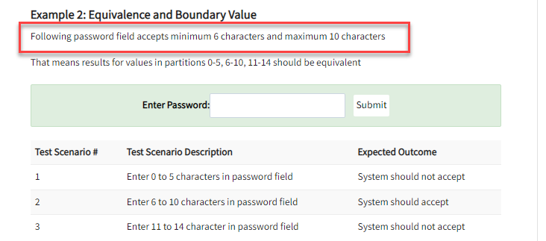

You can use the same ex but testing with boundaries….  If it is current date have test with the invalid date which is yesterday.  Yesterday and January 1 is the date, in-between everything should be passed.

**State transition:** State Transition Testing is a type of software testing which is performed to check the change in the state of the application under varying input. ... In this type of testing, both positive and negative input values are provided and the behavior of the system is

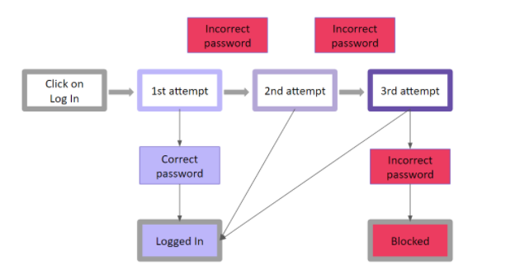observed.[**https://www.qamadness.com/5-test-design-techniques-qa-engineers-should-know/**](https://www.qamadness.com/5-test-design-techniques-qa-engineers-should-know/)

**1st if we give wrong password, it will ask us to enter the password again. If we are giging the valid password, then will login.**

**Error guessing:** Error guessing is the most experimental practice of all, usually applied along with another test design technique. In error guessing, a QA engineer predicts where errors are likely to appear, relying on previous experience, knowledge of the system, and product requirements. Thus, a QA specialist is to identify spots where defects tend to accumulate and pay increased attention to those areas.

Entering blank spaces in text fields.

Pressing the Submit button without entering data.

Entering invalid parameters (email address instead of a phone number, etc.).

Uploading files that exceed the maximum limit. … and so on.

**Source: 5 Test Design Techniques QA Engineers Should Know - QA Madness Software testing company**

**Difference between defect and bug and error**

**Defect is an issue identified after software deployed to production. In other words it’s a difference between actual and expected result**

**A bug is a defect in the developed code found in the development env before product is shipped to the customer.**

**An error is a mistake, misconception or misinterpretation on the part of a software developer/ tester/ analysts or whoever is in contact with the software app development.**

**Advantages of manual testing**

**Live testing, less programming, ui ux testing- look and feel of application, low cost investment- short term only, adaptability to change.**

**Quality control-product based approach- finished product tested.**

**Quality Assurance- process based approach- aims in testing the processes used to create a product.**

**Alpha Testing is a type of software testing performed to identify bugs before releasing the product to real users or to the public. Alpha Testing is a type of user acceptance testing.**

**Beta testing is performed by real users in a real environment. It is also a type of UAT**

**Disadvantages of Manual testing**

**Time consuming, not reusable, possibility of errors, testing limitations- cannot use manual testing for performance testing as pt needs lots of users, gadgets etc.**

**difference between system testing and integration testing - in photos**

**What is test harness? Explain**

**A test harness is the gathering of software and test information arranged to test a program unit by running it under changing conditions like stress, load, data-driven, and monitoring its behaviour and outputs. Test Harness contains two main parts:**

**A Test Execution Engine**

**Test script repository**

**Bug life cycle?** state of the bug, once it will be new, active, qs ready, I will make active, resolved. And closed.

Regression testing : Testing of a previously tested program following modification/enhancement to ensure that defects have not been introduced or uncovered in unchanged areas of the software, as a result of the changes made.

Or Restesting if an existing software after modifications/enhancements to make sure new changes are not impacting the existing code.

Test closure : Test Closure is a document which gives a summary of all the tests conducted during the software development life cycle and also gives a detailed analysis of the bugs removed and errors found.

Positive testing - by giving valid input

Negative testing- by giving invalid input

Critical bug- major system component/ functionality is  completely broken and there is no way to walk around it.  A critical bug is a bug that has the tendency to affect majorities of functionality of the given application

What is pesticide paradox? How to overcome it?

According to pesticide paradox, if the same tests are repeated over and over again, eventually the same test cases will no longer find new bugs. Solution:

Write a whole new set of test cases

Prepare new test cases and add them to the existing test cases

What is Quality Software?

In general, quality software is reasonably bug-free, delivered on time and within budget, meets requirements and/or expectations, and is maintainable.

Black box testing and it’s types ?

White box testing and types ?

Purpose of white box testing : to enhance the security, input output flow through applications, improve the design, usability etc.

What is experience based testing?

What is top-down and bottom-up approach ?

difference between smoke testing and sanity testing?

difference between static testing and dynamic testing?

how will you determine when to stop testing?

what if the software is so buggy that it cannot be tested at all?

how do you test a product if the requirements are yet to freeze?

what if an organization is growing so fast that fixed testing processes are not possible? what to do in such situations?

how do you know the code has met specifications?

what are the cases when you will choose automation testing over manual testing?

what is Configuration management or SCM(Software configuration Management)? - Can call it as masterplan for testing. refer pic.

why is it that boundary value analysis provides good test cases?- because greater no of errors actually occur at boundaries rather than center of the input domain for any test.  so basically in boundary value analysis, tc’s are designed to include values at the boundaries and that’s why BVA provides very good tets cases. If i/p is within the boundary value, its positive testing. if its outsid eboundary value its negative testing. values are like- max, min, inside edge, outside edge.

why is it impossible to test a program thoroughly or 100% bug free? Firstly, software spections and requirements can be subjective and may lead to different interpretations. Secondly, a software prog may require too many i/p, o/p and path combinations asq

Can automation testing replace manual testing? No… Automation testing is just a continuation of manual testing.

is it true that we can do system testing at any stage?

what are best practices to follow while writing test cases?

**Defect cascading:** When a defect is not identified or goes unnoticed while testing, it invokes other defects.

Example : application drployed to calculate salary of employees . Bug in calculating it properly . This not identified which results in other issues in balance sheets , tax payments etc.

there is one which is not fixed or missed, this defect will cause multiple defect in the system. Defect triage call will schedule and with complete with product owner.

**Defect containment:** It is a way of displaying information about the issues and problem reports found in a system.

**TCE(Total Containment Effectiveness)-** This is the % of defects contained or discovered before the product is released,divided by total defects pre and post release, The higher the %, more effective is the development team.

**Defect leakage:** Number of defects missed during the testing by tester or QA. it also called as defect slipping.

**Defect release:** will be releasing the story with known bugs.  Low severity and low priority bugs.

**Priority** is the order in which bug is resolved by the dev team. usually priority is given by QA team.

**Severity** is the severity of the issue. usually decided by testers, BA, scrum masters all together.

**Deffered bug:** Deferred: This is state when bug is expected to resolve in next release but not fixed yet. The reasons may be low priority or lack of time to release. This status is known as “Deferred”.

**What is exploratory testing?**

Exploratory testing allows you to think outside the box and come up with use cases that might not be covered in a test case. For example, you **might perform one test and then ask yourself**, “What if I tried this? What if I didn't do that?

**Proof of Concept** (POC): POC is detailed technical document which will be conducted when team wants to adopt a new automation testing tool. It contains what type of automation tool are going to use and why, scope of automation testing and technical feasibility.

is a broad technical term used in various industries. ... This is when a POC is necessary to showcase your action plan in a small-scale environment. POC in Automation Testing is **usually conducted when the team wants to adopt a new automation testing tool.**

POC - all possibilities of new functionalty.

ROI- Return on Investment - release -  hours? savings. calculting the saving timings.

1st realeas it will be more than manual.

**What is Return on investment (ROI):** ROI, or return on investment, is **a metric to calculate the efficiency of any investment**. In our case, we'll discuss test automation. ... The automated testing ROI helps in finding out whether the shift to automation is worth performing. Just think about the time required to set up and execute test cases with manual labor.

**The Agile methodology** is **a way to manage a project by breaking it up into several phases**.

agile - regression - smoke.

all criticality functions to be run during agile methodology.

Scrum ceremonies:  15 days of sprint, sprint

* **Backlog grooming (product backlog refinement/story time)-** is a recurring event for Agile product development teams. It is a process in which the product owners review their team’s backlog to ensure that its up to date with the latest items and user stories.
* **Sprint planning.-** at the beginning of every sprint, where tasks are created assigned and the capacity or no of hours for particular tasks are discussed and marked.
* **Daily scrum.**
* **Sprint review.-** at the end of the sprint to review what tasks were completed in that particular sprint and which weren’t and the reason.
* **Sprint retrospective.** at the end of every sprint to analyze and learn what went wrong and what went right and how can it be improved in the next sprint.

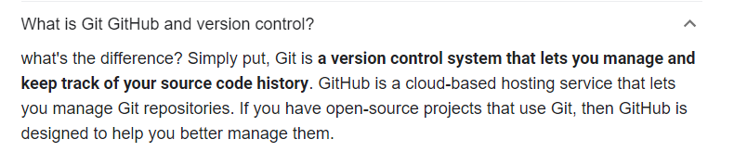

What is Jira tool?

**Jira Software is an agile project management tool that supports any agile methodology, be it scrum, kanban, or your own unique flavor. From agile boards, backlogs, roadmaps, reports, to integrations and add-ons you can plan, track, and manage all your agile software development projects from a single tool.**

**What is complexity?**

**What is azure cloud  used for ?**

What is Azure? At its core, Azure is a public cloud computing platform—with solutions including Infrastructure as a Service (IaaS), Platform as a Service (PaaS), and Software as a Service (SaaS) that can be used for **services such as analytics, virtual computing, storage, networking, and much more**.

What is azure repository: Azure DevOps repos are a set of repositories that allow you to version control and manage your project code. It helps to work and coordinate code changes across your team. It will allow you to monitor code, solutions, builds, commits, pushes, PR's (Pull requests) and branching information about projects.

Testcases status:

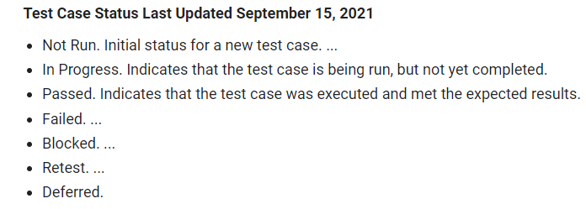

**Blocked :** functional test cases that could not be executed due to an external reason.

**Retest**: Retesting is running the previously failed test cases again on the new software to verify whether the defects posted earlier are fixed or not. In simple words, Retesting is **testing a specific bug after it was fixed**.

**How do you improve the test execution speed ?**

**Speak more leadership quality? There are  around 6 resouces have been tagged to me.**

**Will always give them KT on automation framework setup with complete details in one call.**

**Next session will be on azure devops – git version control, creating repo, cloning version with local.**

**Then push pull and creating PR.**

**API testing session on automation knowledge**

**UAT : What is alpha testing:**

***Alpha Testing*** is a type of acceptance testing; performed to identify all possible [***issues/bugs***](https://toolsqa.com/software-testing/difference-between-error-mistake-fault-bug-failure-defect/) before releasing the product to everyday users or the public. The focus of this testing is to simulate real users by using [***BlackBox***](https://toolsqa.com/software-testing/black-box-testing/) and ***[WhiteBox](https://toolsqa.com/software-testing/white-box-testing/)*** techniques.

Beta Testing of a product is performed by ***real users*** of the software application in a ***real environment***.

**Challenges faced? Web element keep changing.  Microsoft access database I have used for test data as external files… the pipeline was not supporting because the agent pool which have used was not supported by the Microsoft access db. We tried reached the agent pool team to**

**Company questions:**

**What is API?**

**Application Program Interface**

**It is a component that enables communication between 2 different applications.**

**Ex: there may be one app built on Linux platform using Javaand oracle as db,  and another Windows using C++ and my sql server as it’s db.**

**Now Api enables communication between these 2 servers.**

**Waiter is the API which connects customer and kitchen**

**Example on a flight booking site , when we search for flights to and fro , results from various airlines pop up . These are all fetched through the api’s of the respective airlines.**

**Request is sent, response is got.**

**Experience : tested this using Soap UI/ Postman tools in real time. We had various downstreams like sales force, my metrics, Polaris etc . And data used to come to astro through these API’s.**

**DATABASE TESTING and why it’s done?**

1. **To validate existence of values in DB system**
2. **To validate correctness of values**
3. **To validate completeness of values.**

**Mainly SQL select queries used by QA to test this.**

**Testers will need access to the Database model or document where all details of stored procedures(SP), tables , columns and it’s data types etc Is mentioned.**

**Test cases related to tables, columns:**

* **Check table presence in database schema**
* **Check table name conventions**
* **Check number of columns in a table**
* **Check column names in a table**
* **Check data type of columns in table**
* **Check size of the columns in a table**
* **Check nulls fields in a table**
* **Check column keys in a table**

**Below is Structural testing which is white box testing. Just checking the structure of the table.**

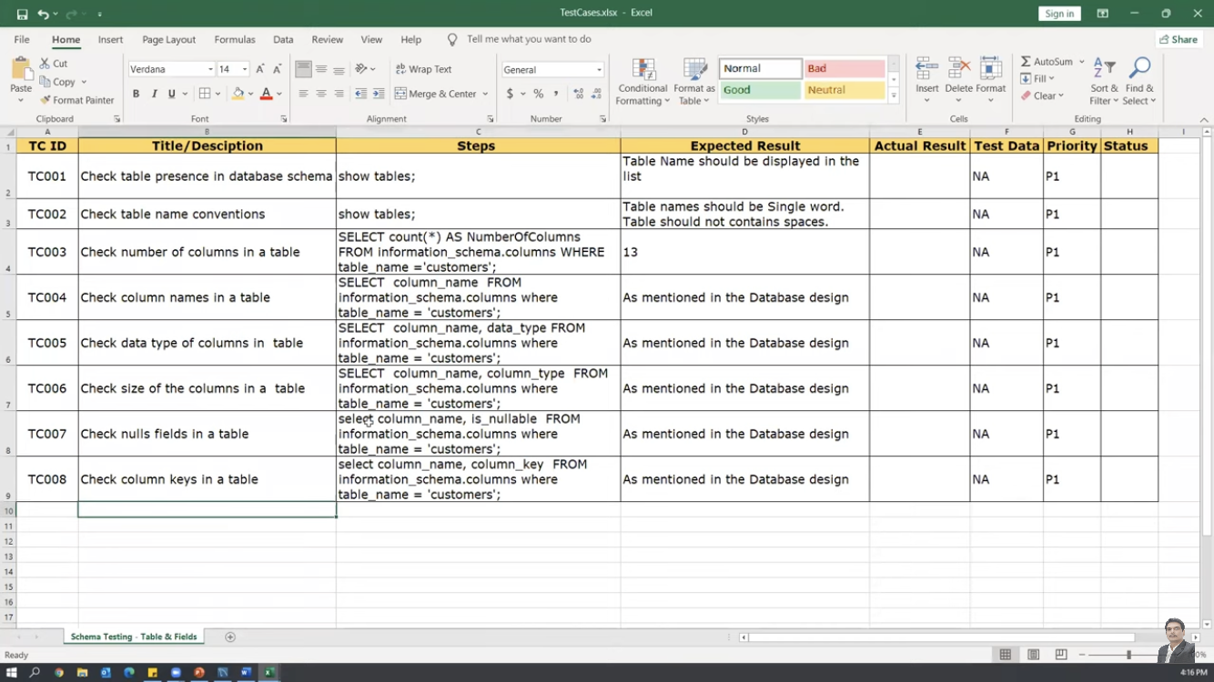

**What is Meta data? It’s data of the data. Example, I want to know the details of few columns in a table, that data will be available in some other table ..**

**STORED Procedure Testing**

**SCRUM- Scrum is a framework based on agile to define plan execute and deliver projects. It is a time box and iterative process.**

**SPRINT- Fixed time interval decided by the SCRUM team to complete any tasks/user stories.**

**PO/ product owner- works with customer to get requirements and creates user stories- accountable for maintaining the backlog.**

**Scrum Master/ is like the leader in the team and helps the team in resolving obstacles and makes sure Agile methodologies are followed.**

**Product Backlog- prioritised list of user stories. Only PO can delete Product Backlogs. Anyone in the team can go and add it.**

**Scrum ceremonies - Daily stand up, sprint planning, sprint review and Sprint Retrospective.**

**EPICS- Epics are huge pieces of work which need to be converted into smaller ones. We can also say that epics are big requirements which cannot be delivered into one sprint and should be divided into smaller more manageable pieces.**

**User Stories- User stories are smaller or individual requirements that a client wants. User stories cover just the information required to work.**

**JIRA Tool:**

**First create Project**

**Create epics - link attachments, give priorities , acceptance criteria, summary , description etc.**

**Create user stories -link it with the particular epic.**

**Can add labels ( tags in VSTS) - will be easier to sort .**

**Create Sprint- Drag and drop stories, start sprint.**

**Filters( Jira)-  ( queries) in VSTS**

**Ex- project = myjirap AND labels= Section1**

**Can use OR**

**Dashboards- create**

**Dashboards are designed to display gadgets that help in visualisation and organisation of our project’s assignment, achievements, progress etc.**

**WORKFLOWS- shows the set of Statuses and transitions and issue moves throughout its life cycle.  Includes TO DO, in progress, testing, done .  - can be customised.**

**Difference between Mobile and web Apps**

**Mobile applications give great UI/UX experience and can be integrated with the hardware perfectly**

**Testing for both applications mainly differs when it comes to comparability, internet connection and User interaction.**

**C- when it comes to web applications for different types of browsers that are available in the market, the desktop run applications are easier to test when compared to mobile app. In mobile app they need to be tested on each mobile decice to access their behaviour and various hosts.**

**Mobile devices have capacity limitations like2 or4 GB RAM . Hence mobile app testing make it hard if are slow to use.**

**User interaction -  in desktop it’s limited to point, scroll and click**

**In mobile - touch , swipe and pinch**

**For the ui , greeting  Testing might not be a trouble because the interaction is simple**

**Internet connection -  majorly mobile and web apps run online . Hence need to be tested with different internet connections.**

**Real time - testing on iPhone X and iPhone 8 - bigger and smaller screen - UI issues**

**Internet challenges**

**Amyca - cognitive app - purpose of cognitive app is to stimulate and assist human thinking and decision making.**

**Astro - AI baded hybrid app - AI thinks on its own and makes decisions independently**

**Native apps developed specially for one platform and coded using specie programming language. - only IOS, only android . Ex: temple run, candy crush**

**Hybrid apps - can be run on multiple platforms - ex Facebook, twitter.**

**If it is REST, you send the data in JSON format**

**If it is SOAP, we send the data in xml format**

**CI CD- gut repository , clone to local , pull and push requests .**

**Push to main brain**

**Pull from main branch to local - pull will have conflicts**